**Search engine optimization**

Types of SEO

1. on page - optimization in the html tags, content quality, keywords.

2. off page - other links like backlinks, internal linking, and page mvps.

3. technical - overall performance like security and user experience and structure.

Factors for seo

1. high quality content

2. keywords in meta title

3. backlinks- links on websites other than your own

4. user engagement

On page – content, architecture, html

Off page – reputation, links, user experience

**Qu quality of content**

Rs -research the keywords for the targeted audience

Fr – freshness – update the content as per time. (up to date) – eg google news

Dt – depth – your content must be enough to answer the user questions

**Success factors**

1. cr - crawl search engines must easily crawl your pages

2. mo – updated for today's mobiles.

3. du – duplicate, use canonicals, redirects

4. sp – speed of your site

5. urls – make keyword to your page address

6. http or https – https use tls over http

**Urls**

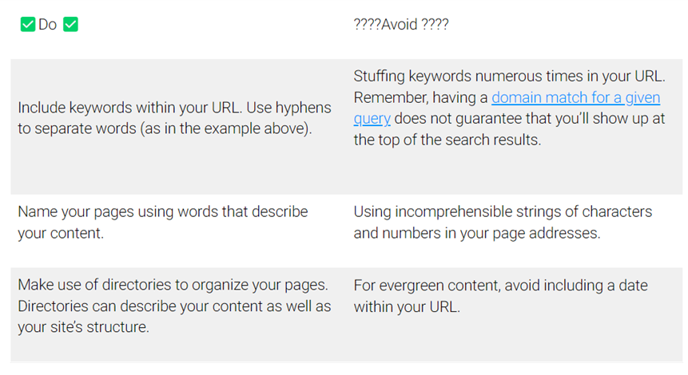

HTML Part

Tt – titles Html tells or understands what a page is about and the title conveys what pages are about to users as well as search engines.

Ds – description tag used to describe your page described in search listings.

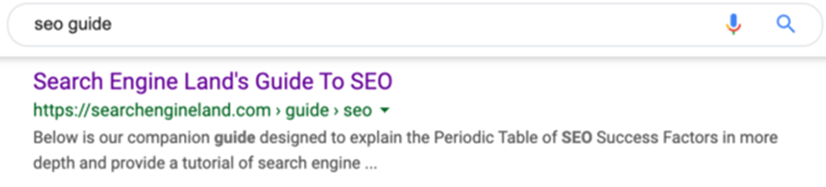

St structure – gives better understanding of context of the page

**Trust authorities in SEO**

Au Authority – authority is everything covet links, shares and other signals.

En engagement – how much time users can spend on their time on a website.

Re reputation – sites operating the same way for years carry weight.

Au Authority

**On Site SEO**

**3 Parts –** Content, HTML, Website Architecture

Content – Just like king without it nothing works

1. EAT – Expertise, Authoritative, trustworthiness.

Google search quality guidelines

Conduct Reputation Research - Eliminate your domain as one of the search results and look at things like reviews, scam, and fraud.

If you want to improve your E-A-T, you need to stop:

1. Auto-generated content.
2. Overwhelming advertisements or CTAs.
3. Guilt-tripping calls to action.
4. Overtly-salesy YMYL content.
5. Lack of customer support.
6. Not addressing bad reviews or Q&A.
7. Distracting ads that are hard to close.
8. Meaningless SEO content.
9. Low-quality local landing pages.
10. Mysteries about your brand or authors.
11. Paid link campaigns

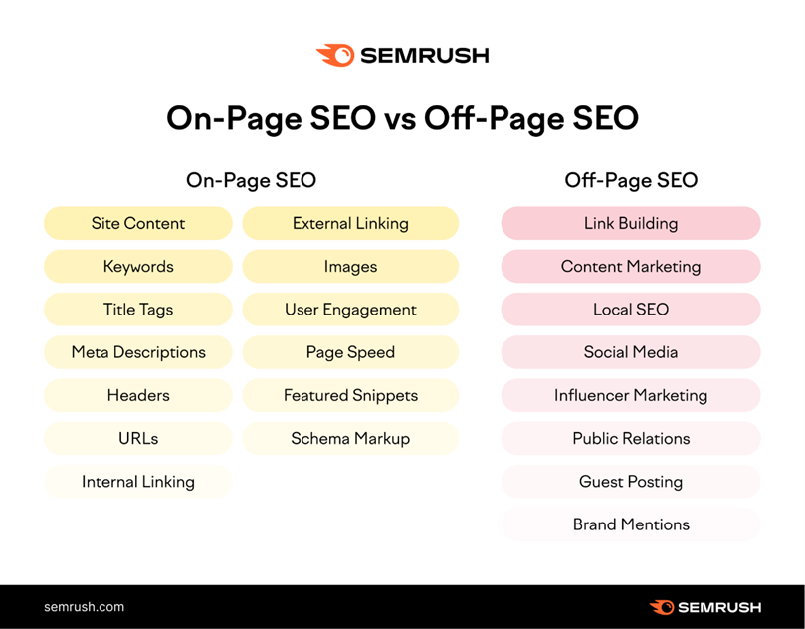

Keyword in H1, First paragraph, subheaders

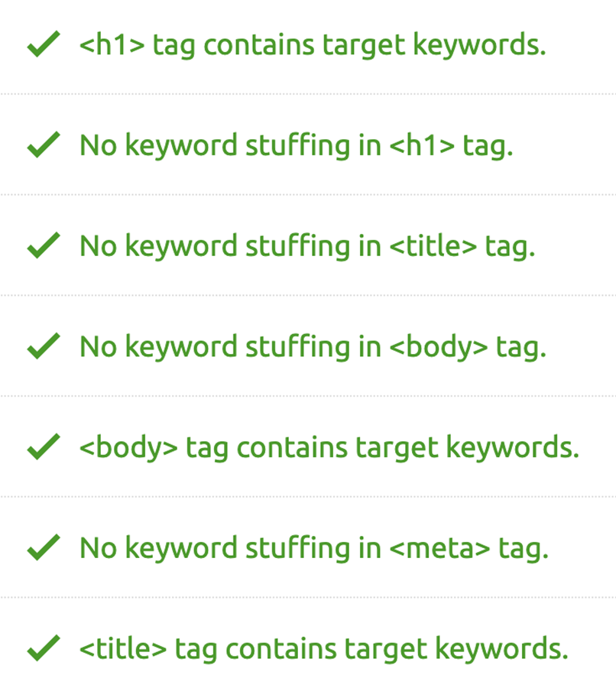

Optimize title page.

Keep it brief. We recommend keeping title tags between 50 and 60 characters, so Google doesn’t cut them off.

Include your target keyword. This helps both Google and users determine what your page is about.

Be unique. Avoid duplicate title tags so that each individual page’s purpose is clear to Google (and users know what they’re clicking on).

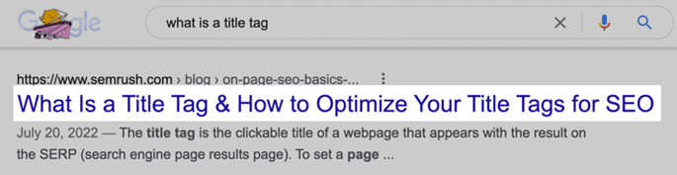

Write Engaging Meta Descriptions

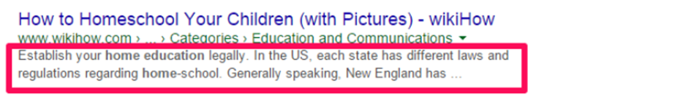

Consider mobile devices

Include your target keyword

Visual hierarchy

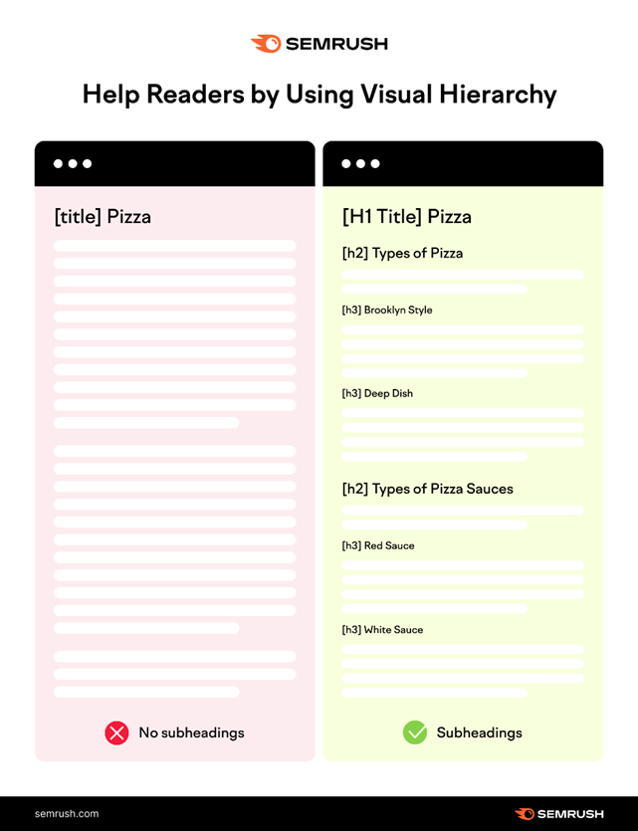

Optimize urls

Internals links

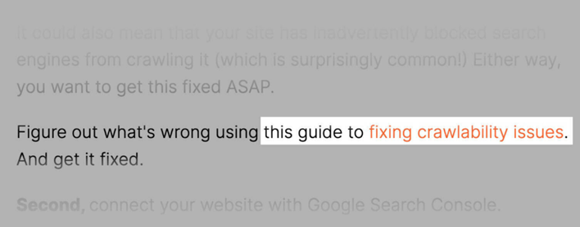

They signal to Google that the linked-to page is valuable

They help users navigate through your website (and keep them on your site longer)

Include and optimize images

It provides context for search engine crawlers

Keep it brief. Screen readers stop reading alt text after about 125 characters.

Include a target keyword. Include your target keyword for context (but don’t spam keywords for the sake of it).

Don’t add alt text to decorative images. Graphics like horizontal page breaks, a magnifying glass in a search bar, etc., don’t require further explanation.

Don’t include “image of” or “picture of.” Alt text implies that it’s describing an image, so there’s no need to waste characters on these phrases.

Be descriptive. black-puppy.jpg is better than puppy.jpg

Be succinct. black-puppy.jpg is better than my-super-cute-black-puppy-named-jeff.jpg

Don’t stuff keywords. black-puppy.jpg is better than puppy-dog-pup-pooch.jpg

Use dashes between words. black-puppy.jpg is better than black_puppy.jpg

User engagement

Page speed

Keywords – should be long, understand your target audience.

Subheading

Bulleted list

Don’t use over keywords.

Keep sentences and paragraphs brief.

url structure

**On - Page SEO**

CheckList of on page SEO

Validator List - [List](https://docs.google.com/spreadsheets/d/1Mz0YKL_8tuQsNSC_q5IYqCJTESFfChAsqROYUcKXTBs/edit?usp=share_link)

1. Meta Title tag
2. Meta description
3. Meta keywords
4. URL optimization
5. Heading tags
6. Internal and outgoing links
7. Anchor text optimization
8. Plagiarism
9. ALT text/ ATT
10. Sitemap - Sitemap.xml -> crawler, Sitemap.html -> user

Sitepmap.xml - for web - crawler - google or bing bot - collections of links that crawler has to click

Sitemap.html - for user or user

1. Robots .txt file - this will will never be rank on any - file for personal data - like banking information
2. Page load time - <https://pagespeed.web.dev/>
3. Ssl certificate - encrypted link web browser and server - ultimately website is secure or not - https has ssl certificate while http has not
4. Canonical tag - remove duplicates - like https, http
5. Broken links Redirection (404, 301, 302) -

404 - page not available in site but landed on our site if domain name is correct

301 - permanent redirection

302 - temporary redirection

1. W3c validation - check web documents, if fail all traffic gone, problems in website
2. Open graph tag (og tags) - when share link on social media it preview the website in a box - <https://icut.in/open-graph-checker>
3. Structured schema data - improves presentation of websites - <https://validator.schema.org/>
   1. Website
   2. Breadcrumbs
   3. Person
   4. Local business
   5. Org
   6. Article
   7. faqs
   8. Product
   9. Event
   10. Recipe
   11. Job posting

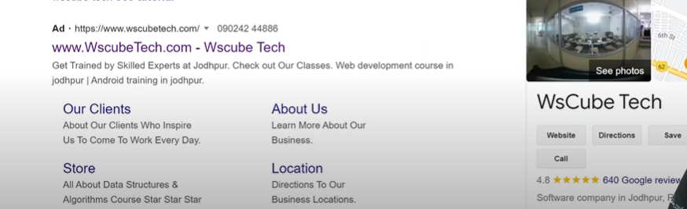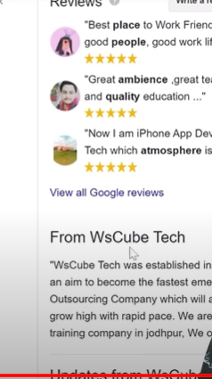

1. Design and user experience - mobile and desktop view
2. One topic at a time
3. Update content as per time.
4. EAT - expertise in content - authorities content created by credible source - trust content should be factually correct and backed up other links
5. Over intrusive pop ups - aggressive ads - ads in website
6. Text to html ratio - must be above 20% - <https://smallseotools.com/code-to-text-ratio-checker/>
7. Contrast ratio - web content accessibility guidelines (WCAG)
   1. AAA - 3:1 - 18 px bold/ 24 px
   2. AA 4.5:1 - for color blind

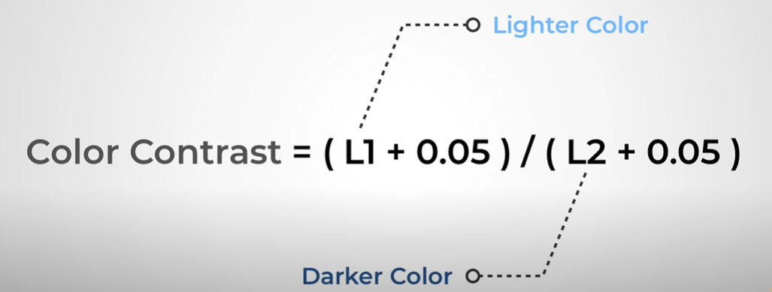

1. Font size and type - 16 point - heading 20 point
2. Menu
3. Page summary - overall summary of page
4. Faq - different page for faq
5. Mobile friendliness - how website show in mobile site - <https://search.google.com/test/mobile-friendly>
6. H1 h2 h3 - increase readability - 1page 1 h1 primary keyword - h2 secondary keyword
7. Searchers intent - intent behind query - search apple - apple website……..
   1. Informational - blog
   2. Navigational - looking for specific place - like something login
   3. Transactional - buy something
   4. Commercial - sell product - offers on products

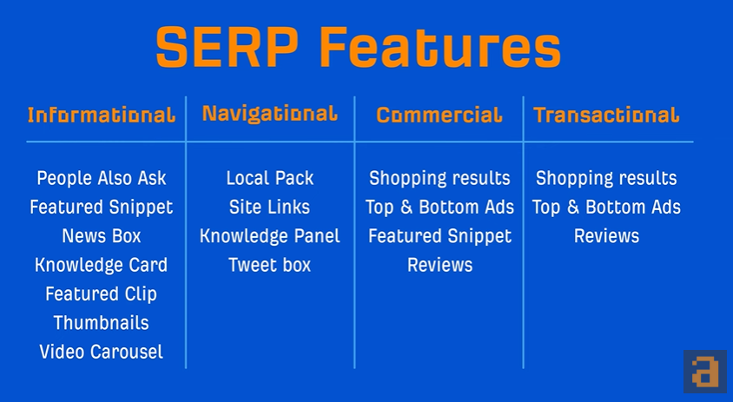

1. Breadcrumb - navigation of website example home -> category -> sub category

Crawling - Indexing - Ranking

CDN content delivery network

SiteMap -

1. List of your websites url
2. act as a roadmap to tell search engine and audience what and where content is available
3. Two different sitemap - for search engine - for user

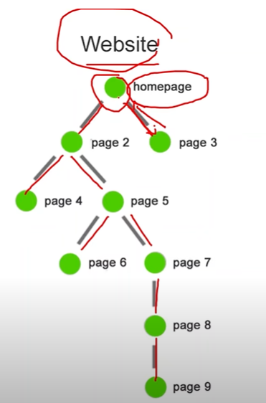 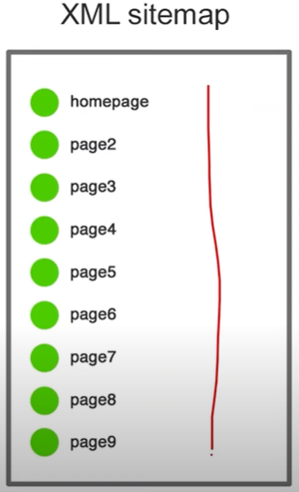

**For crawler** (sitemap.xml) list of website important page so that search engine can crawl them all it makes search engine understand your website structure

To check sitemap [www.websitedomain.com/sitemap.xml](http://www.websitedomain.com/sitemap.xml)

**For user or audience** (Sitemap.html) list of links to the main pages to the website. It helps users to find the desired section or page on the website.

To check sitemap [www.websitedomain.com/sitemap.html](http://www.websitedomain.com/sitemap.html)

To generate sitemap use <https://www.xml-sitemaps.com/>

C panel helps to manage web hosting

**To publish sitemap on your website on c panel of your website -> click file manager -> public_html -> upload sitemap**

Robots.txt -

Hide the pages that we don't want to crawl

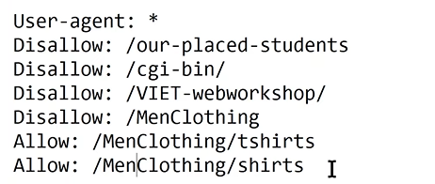

User-agent: * means all search engine bot will not crawl these pages

AMP - Accelerated mobile pages - help to make mobile page fast

Canonical Tag - remove duplicates - like [www.domainname.com](http://www.domainname.com), https.[www.domainname.com](http://www.domainname.com), http.[www.domainname.com](http://www.domainname.com). Canonical tag redirects one main site.

<link rel=”canonical” href=”url link” />

Broken Links -

Page remove

Content removed

External links removed

Misspelling

**404** - missing page in web page or misspelling in our site.

**301** - permanent redirection - website or webpage moved - ownership changed like jabong and myntra - jabong site moved to myntra - http to https

**302** - temporary direction - page is updating - maintenance

Schema .org - Structured Data -

1. Helps search engine better understand the info on website
2. It improves the appearance of your website on SERP (Search engine result page)

Open graph tag (OG tag) -

1. When share link on social media it preview the website in a box
2. Twitter card - same as og tag but for twitter

**Google Analytics**

Google Analytics is a tool in depth insight into your website and its performance

It is used to track website activity traffic, session duration, bounce rate etc

Universal Analytics || Google analytics 4 (recent version of universal analytics 2023)

Property - website which we have to track data

Session - period of time user spend

Session duration - average session

Session duration must be high

User > Session, User = Session, user !< Session

Bounce rate - user visit but does not interact with website

Bounce rate should be less

Traffic Channel

Organic search - simply search from search engine

Direct - paste direct url in search box

Referral - from external link or backlinks

Social media - insta, facebook

Other

User Retention - how much user retain in your website

User by time of day - time of day

Session by country - from where your website get clicks or viewed

Session by device - desktop, mobile, tablet

What pages your user visit - pages in website that user grab their attention

Organization, Account, Property, View

Organization - it represent the company or brand -

Account - individual to access the data you need - google ads, google analytics

Property - website or mobile app you want to track

View - defined information from the property - to track a defined thing - eg. - how much traffic from delhi

Goals - track how often perform certain completed action from website - eg. - to track how many user click on some page of website

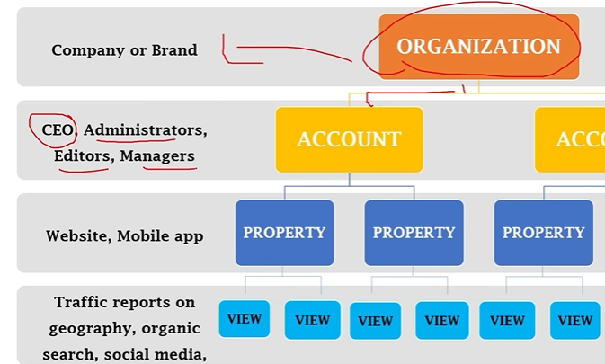

Create organization - Top All Account -> visit platform home -> Click Administration -> create organization

**Real time data** - sidemenu realtime

Overview - top active page - top locations - top social traffic - top referrals (backlinks)

Locations - shows worldwide locations - city location

Traffic Source - Direct, Organic, Socials

Content - on which page user active

Event - type of goal - specific action

**Audience** - side menu audience

User - new user

Sessions - number of session per user

Page views

Avg Session Duration - Bounce Rate

Add Segments - Shows all user but to filter we use segments - paid, organic, referral traffic

User Explorer - client id - explore each and every client id - shows complete info - avg session, bounce rate, revenue, date last seen, device category, acquisition (first time visit to website)

Analytics 4 - User id

Universal Analytics - client id

Lifetime and cohort analysis

Lifetime value - user gives throughout time span value - goal completion, views

Cohort analysis - group of common characteristic

Demographics - population, Age, Gender

Interest -

Affinity - interest in which user in

In market segment - based on recent search

Geo - particular region

Language - how much user read - like en-us, en-uk

Location - from where user visit

Behavior -

New vs returning user

Technology -

Browser and os

Network

Mobile - shows traffic from mobile devices

Devices - which device is used - apple, xiaomi

Cross Devices - same user from desktop and mobile visit

Custom - make custom metrics (add up to 5 parameter)

Benchmarking - compare with your competitors

Location wise

Devices based

**Acquisition** - First time user come

Organic. Social. Direct, Referral, Paid Search

All Traffic - Channels - organic, direct, referral

Treemaps - provides gui of all traffic

Source/ Medium - google organic, google ads, bing, yahoo, search engine

Google analytics - collects information from all sources

Google Search Console - collects information from google search engine

Connect google analytics with google search console

Settings -> select property -> property settings -> scroll down search console -> click then add

Google Search Console - collect insight data

Impression - no. of time your url viewed by user from search engine

Clicks - how many clicks on your websites

Ctr - clicks through rate

Plugins - twitter button, fb button, yt button

Users flow - flow of user and divert - one page to another page

Campaigns - ads run on website

Landing page - page from which user visit our site

Exit page - page from which user end our site

Site Search - search option like in amazon

Goals - predefined activities that user will hit

Total 20 goals at a time - change but not delete

Example - if a user visits my web. Then user at least visit 4 pages

User visit then at least spend 1 min of time

If video then must play the video

How to create goals in google analytics

Admin -> Select Account -> select property -> view -> select goals -> new goal

Conversions

Time lag - 1st visit the site then in how many days user completed the goal

**Google Webmaster/ Google Search Console**

Google Search Console act as a bridge between the crawler and your website which will act as a recommender

What are the error and recommendation, how crawler interact with our website

Monitor, maintain and troubleshoot your site presence in google search results

Crawling

Reindexing

Performance - google search engine result page(SERP) data, query, impression

Page impression

Page clicks

Malware, Spamming

Security related updates

Property - Domain based, URL prefix

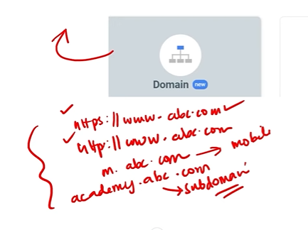 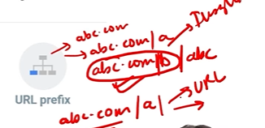

Domain based - Full domain - only DNS record verification

Eg - [www.domainname.com](http://www.domainname.com)

URL Prefix based - subdomain - many types of verification

Eg - [www.domainname.com/subdomain.html](http://www.domainname.com/subdomain.html)

For sharing properties - Owner - Full - Restricted - only view the reports

**Coverage/Pages Report** - Inside Index section

Shows pages, errors in pages, valid with warnings, valid page, excluded page

**URL Inspection Tool** -

Current indexing Status - web page is indexed or not

Testing live url - inspecting page

Requesting google to crawl a page

Information about page loaded resources - check errors, check mobiles friendliness

**Performance -** How webpage performs in search engine

Clicks

Total Impressions

Average CTR

Average Position

**Removals -**

Temporary Removals - remove page from google search for 6 months

Outdated content

Safesearch Filter

URL Parameter - same content but different query or filter and changed the link - no crawling - use robots .ext to resolve this issue

**Enhancements** -

Based on structure data or schema data (enhance search view of website)

Eg - logos, breadcrumbs

**Security and Manual Actions -**

Manual Actions - when search engine representative checks the webpage and found suspicious the this action will occur

* Some url will removed from SERP

Third party spam

Unnatural links

Security issues - id user visit on your webpage and found something suspicious

* If user enters their banking details and google found suspicious then this issue will occur in webpage

Not secure websites

Malware injected

**Links -**

Externals, Internals links

Gives only overview

**Crawl Stat Reports -**

Settings -> Crawling -> Crawling Stats

It tells crawling history of your website

**UI and UX**

UI is cosmetic part whereas ux is support for functions

Ui focus how interface looks ux focus how interface operates

**User Interface** - the point of human contact and interaction on a device is the user interface, includes displays, keyboards, mice and pointing device

Eg - CLI - command line interface is a window in order to communicate with software

Type command and receive system response

Lmkdir to create folder - lmkdir path

GUI - enables people to engage with just an operating system

Tools - sketch, adobe xd

Font, menu design, button, icons

Testing to test the design the design like the functions are working according to their requirements

Wireframing - layout of webpage that demonstrates how the interface works and looks

**User experience** - UX designers focus on crafting products that are easy to use and understand, the concept of user-centered design takes a central stage in UX design process

It is a process of determining how a person will engage with a product. Understanding user’s complete journey and translating it into a product

**Example - ketchup bottle**

UX focus on -

Simplicity of use

Enjoyment, engagement

Feedback - take rigorous surveys and feedback to ensure complete customer satisfaction

Error prevention - ux designers try to keep the error and warning minimal as possible

Flexibility - maintain flexibility to be able to adapt to additional upgrades

Research in understand the aim of audience, their need, and wants

How user interact with things

Tools - research, problem, communication - meetings, writing emails, creating proposals

**UI vs UX**

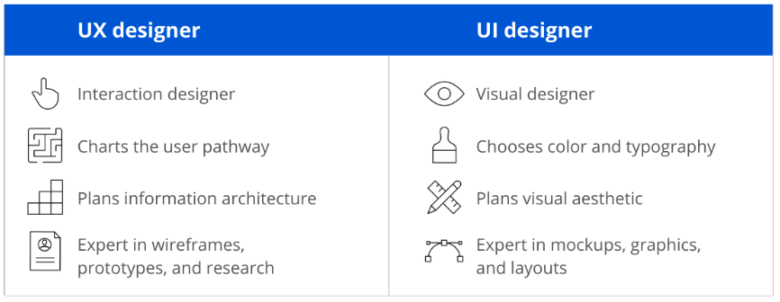

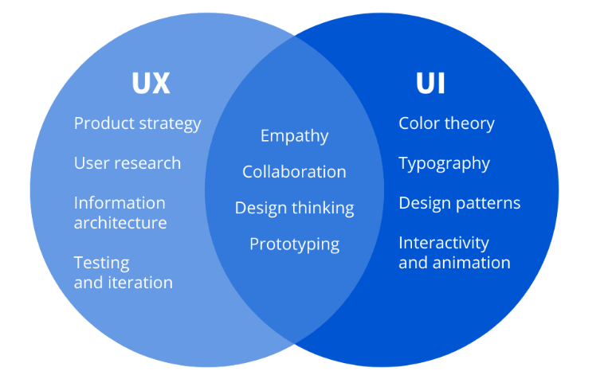

**UX design -** process of enhancing user satisfaction with product by improving the usability, accessibility

Design and branding

UI - all aesthetics part referred to user interface design

Color palette, images, button placement and menu

Touch swipes also covers in ui

UX - refers to persons interaction with product or service

Eg - buy something then how easy to use website to quickly find the what you are looking

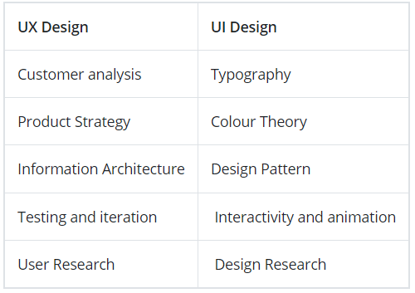

**UX refers to resolve user issues, where as ui refers to visually appealing interactive interfaces**

UX can refer to any product, service or experience, whereas ui refers as digital experiences

UI and UX WorkFlow -

1. User flow - customers take several different paths. User flow is visual representation of the various path that can be taken while using path

Flow chart would be made with customer engagement

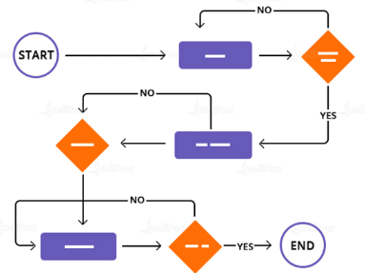

1. Wireframes - express the layout and design of each and every page

Structure and flow of product

Overview of interactive products to establish the structure and flow of possible design solutions

1. Wireflows - combination of wireframes and flowcharts. Use arrangement of separate screens as diagram pieces

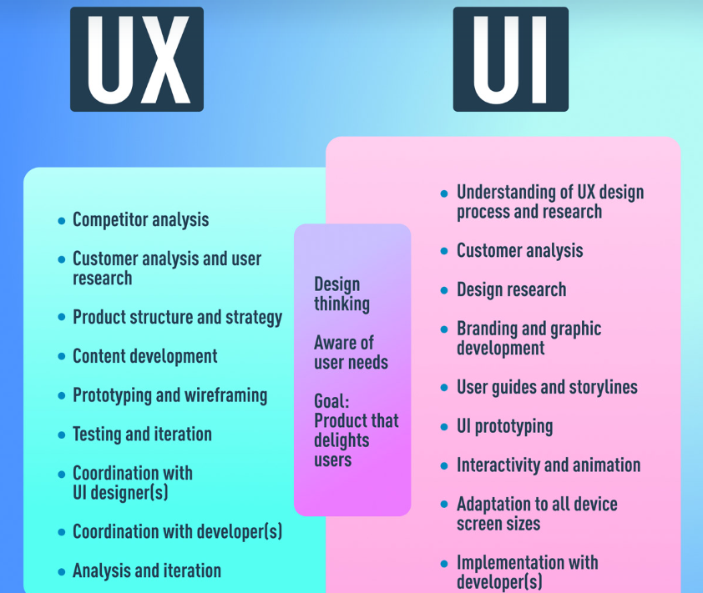

Suppose we have an app and hire a ux developer for user needs and research for features and deploy and then when download the text is barely visible and keeps hitting the wrong button by mistake. So we want ui developer

Its flip side is a great website with animations and on point color schemes.

UI designers are tasked with deciding how the user interface will look, UX designers are in charge of determining how the user interface operates.

Research - ui - crafting appropriate designs, ux - interested in user expectations

Strategy - scope - structure - skelton and surface

Empathize - define - ideate - prototype - test

Universal design

**HCI - Human Computer Interaction**

How people interact with computers and other digital technologies.

The goal of HCI is to create user-friendly and effective digital products, services, and systems that meet the needs of users.

HCI Focus - user, goal, interface, context

User - individual or group who work together on a project is referred to user component

Goal - When using a computer, a user always has a purpose or aim in mind. To achieve this, the computer presents a digital representation of things.

Interface - An essential HCI element that can improve the quality of user interaction is the interface. Many interface-related factors need to be taken into account, including the type of interaction, screen resolution, display size, and even color contrast

Context - HCI is not only about providing better communication between users and computers but also about factoring in the context and environment in which the system is accessed.

Goals of HCI

* Possess a thorough knowledge of user interfaces for computing systems.
* **Create approaches, strategies, and resources that let users access systems in accordance with their requirements.**
* Ensure that users are able to communicate or engage with the systems effectively by adjusting, testing, refining, and validating.
* **Always prioritize end users and build a solid HCI foundation.**

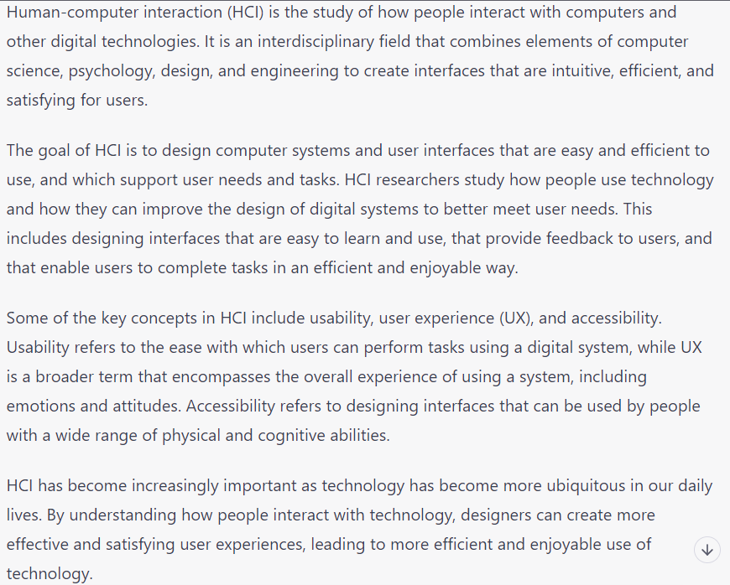

Human Input - Output Channel

Input - sight - iconic memory, hearing - echoic memory, touch - haptic memory

Sight - like 13, B example

Hearing - 70% above volume gives pop up

Touch - feedback from mouse and touch, haptic feedback

Output/ Effecters - fingers - haptic feedback, head or body position - face unlock, voice - voice commands

Human Memory - Sensory, Short term, long term memory

Sensory - acting as buffer stimuli received from sensors and overwrite the data

Eg - 13 and B example

Short term - less time - less capacity - chunks -> group of things

Eg - phone no., otps

Long term - episodic, semantic

Information stores

Loss of information

Retrieval of information - recall something

More capacity

More time to access

Episodic - life events

Semantic - skills and facts

Thinking: Reasoning and Problem Solving

Deductive reasoning - truth and validity clashes

Inductive reasoning - generalizing cases we have seen to infer information about cases web have not seen

Abductive reasoning - method to derive explanation -> Actions - event

Problem solving - reuse of knowledge - insight

Reuse of knowledge - retaking solution of previous occur problem

Insight - in depth knowledge of things

Example - forget pass - hit and trail

**Norman's Model of interactions**

Example turn on light on night for study

1. Establishing the goal
   1. Complete the task
2. Forming the intention
   1. To turn on light
3. Specify the action sequence
   1. How to complete
4. Execute the action
   1. Complete the task
5. Evaluation the action
   1. Check the output
6. Interpreting the system
   1. Getting desired the output and do again
7. Evaluating the state
   1. Is is sufficient output

**Gulf of execution :** difference between user formulation of actions to reach goals and actions allowed by system

Must be small

Difference between human goal actions and system generated actions

Eg - human goal actions, system actions

**Gulf of evaluation :** if the distance between the physical presentation of system state and expectation of user

Must be small

Eg - interpret the system result, like pandas in py to interpret the data

**Ergonomics -** how arrangement made to seamless the process of interaction between human and machine

1. Arrangement of controls and display - logically group the system

Eg - we grp the google apps

1. Physical environment of interaction

Eg - light - bright, light, temperature, noise

1. Health issues
2. Use of color - aesthetic colors, bright colors

Eg - don’t use for bright colors, traffic light example

Phone battery color percentage - green, yellow, red

HCI - giving much and more comfort to user

**Interaction Styles -** better interface, better interaction

1. Command line interface - easy for computer but hard for user
2. Menus - set of options
   1. eg - payment method - upi, internet banking, cancel
   2. Switch case in programming - add, sub, multiply, divide
3. Natural language - comfort for human but very hard for computer or system
4. eg - pitch - cricket pitch, sound property
5. Question and answers - restricted to domain
   1. like akinator
6. Query dialog - but user has to in depth knowledge
   1. eg - sql query very related to natural language
7. Form fills - like to form the fills but choose field

Mostly used in data entry and retrieve

eg - name - alphabet, number

1. Point - Click interface
   1. Like google maps - where we point locations and get information
2. **WIMP Interface** - Windows, Icons, Menu, Pointers
   1. Windows -
      1. includes text, graphic, icons, images
      2. More than 1 windows
      3. Scroll bars
      4. Minimize, resize, close - frequent used by user
   2. Icons -
      1. Small picture represent a window
      2. Iconifying the window - shrink the windows into icon
      3. Easy access
      4. Realistic obj or symbols
      5. Must to easy to interpret by user
   3. Menus - set of options
      1. Pull down menu - give user to respective items
      2. Cascading - if many items then
         1. Like amazon - fashion - mens - womens - kids
   4. Pointers - how to point and select the option
      1. Arrow - direction
      2. Hand - more interactive to user
      3. Eg - to resize screen pointer changes
   5. Dialog box - urgent information
      1. Decision - Save or not - Alert message
   6. Toolbar - vertical and horizontal
      1. Function specific
      2. eg - Word processing, websites

**Keyboard Accelerators -** or shortcuts

Menu open - show shortcuts

eg - Copy paste shortcut

eg - Like find - ctrl f

**What is a design?**

Achieving goals with constraints

**Goals** - objective - what is purpose, who is it for, why they wanted

**Constraints** - restrictions - what material standards, how much cost, time required, health and security issues

It is not possible to achieve all goals with constraints we use trade off

**Trade off -** choosing which goals or constraints can be ignored so that others can be met

Eg - bike helmet - protect skull but lightweight - so protect skull priority and light weight may be secondary

**Interactive System Design life Cycle**

Requirements -> analysis -> design - > implement and deploy

^ evaluate <- prototype

Requirements

Analysis - scenario, models and concluding points

Design - fulfill all goals with optimized solution

Prototype - early version of system or a sample - evaluate - open to feedback for user - improvement ready

Implement and deploy - hardware requirement, writing final code, documentation

**User centered design UCD -** iterative process - interact with user - taking opinion - needs of user - until all requirements met

Specify context -> requirements -> produce design and solutions -> evaluate designs

**Specify context of use** - target audience - your user - type of user - how user use product and why

**Requirement -** user requirement - business requirement - team -> marketing - researcher - developer

**Produce design and solutions -** get problem and find optimized solution - design prototype - early version of system or sample

**Evaluate -** usability testing how feasible user use the product - context of use

Requirement satisfied if pass otherwise then start again

**User focus -** know your user - what it is doing - what is user - what are their needs

1. Who are they? - technical - non technical, age, gender

Sometime it hard to find target audience - like word is used by every user in industry

1. Probably not like you - design product based on you but every user id different
   1. Must be flexible
2. Interact with them - interact with different user and open to collaborate
3. Watch them - observe them using their actions
4. Use their imagination - if i am that user what i will do

**Shneiderman's 8 golden rules of interface design**

1. Strive for consistency - don't use drastic changes
2. Enable frequent user to use shortcuts - use shortcuts - to quickly execute things
3. Offer informative feedback - like haptic feedback in mobiles - like keyboard feedback
4. Design dialogs to yield closure - like when we install software it shows process - processing percentage
5. Offer simple error handling - if user done some mistake then there is a solution to correct that

Eg - renaming the name, install and reinstall software

1. Permit easy reversal of actions - undo option
2. Support internal locus of control - user is everything and initiator of everything

Build trust to the user and good for interface design

1. Reduce short term memory load - don’t complex the things - simple interface

Use recognition not retrieve because recognition is easy

**Norman's 7 principle for transforming different task into simple ones**

1. Use both knowledge in world and in the head
2. Simplify the structure of task - make subtask and then combine
3. Make things visible - execution of task - execution in progress - execution completed - phase of task
4. Get the mapping right - eg - electric switches mapped to number
5. Exploit the power of constraints -
6. Design for error - undo option
7. When all else fails, standardize - car example

**Landing page -** Landing pages are for to making leads and achieve some objective or **call for action** and main focus on **marketing**

**Web Page vs Landing page -**

Website page are for exploration and information purpose while landing pages are for to convert leads and achieve some objective, goal or **call for action** main focus on **marketing**

No distractions in landing page but in website there are distractions

**Elements of Landing pages**

1. Title - main objective - values we added - clear - concise - attention grabbing
2. Subheading - provide more details about the product or service how we deliver or create the value
3. Call to action - button or link to get leads - marketing term refers to next step that marketer wants for user to take next step - sign up - start - try for free - leave your email
4. Use scarcity (short supply) techniques like - limited offer - limited seats
5. Visual - show your product that is being used or a sneak peak of product
6. Features - how product works - product in action - some unique features - (like video call - live captions - background filters)
7. Testimonials - statement from past customer that describes how a product or service helped them
8. Maintain attention - limiting a lot of stuff
9. FAQs - facts and any objections handling
10. Form - If the landing page is designed to capture leads, a form will typically be included for visitors to fill out with their contact information.
11. Last call to action
12. Founders note - our mission - story behind the product or service
13. For Call to action - 2 types - Double and single opt in - double means - when email enters then confirmation on email - single opt in - simple enters email

**Optimize landing pages** - refers to process of **enhancing or improving the each element on your landing page** to increase conversion or the goal

1. Keep important part above the fold
2. Use scarcity (short supply) techniques like - limited offer - limited seats
3. Powerful call to actions - encourage audience to complete the goal by the owner - always in front of user - multiple locations
4. Add testimonials about product and services
5. Visual - show your product that is being used or a sneak peak of product
6. Features - how product works - product in action - some unique features - (like video call - hd recording - background filters)
7. Founders note - our mission - story behind the product or service

Bounced landing pages - means user come and simply exit without giving lead to site

Unbounced landing pages - means successfully collected the lead

**A landing page** is a web page that is specifically designed to convert visitors into leads or customers. There are several key components that can make up a successful landing page, including:

Headline: The headline is the first thing that visitors will see when they arrive on the landing page. It should be clear, concise, and attention-grabbing.

Subheadline: The subheadline expands upon the headline and provides more detail about what the landing page is offering. It should further entice visitors to stay and learn more.

Call-to-Action (CTA): The CTA is the button or link that visitors click on to take action. It should be prominent and clearly communicate what action the visitor will be taking, such as "Sign Up Now" or "Download Your Free Guide."

Images or videos: Including relevant images or videos can help to visually communicate the value of the offer and increase engagement with the page.

Benefits or features: Clearly outlining the benefits or features of the offer can help to persuade visitors to take action.

Social proof: Including testimonials, reviews, or social media mentions can help to build trust with visitors and increase the likelihood that they will convert.

Form: If the landing page is designed to capture leads, a form will typically be included for visitors to fill out with their contact information.

Navigation: Unlike regular web pages, landing pages typically have limited navigation options to keep visitors focused on the offer and prevent distractions.

**Google Adwords -**

Different compaigns

website traffic, Sales leads, App promotion

Compaigns type -

Search, shopping - buy somthing, video, display-pop ups in different websites, Video - on youtube, app install ads- like on playstore

Keyword -

Broad

Phase match ""

Specific []

**Product Management -**

5 Skills

* sense of design - UI and UX
* analytical skills
* understand of technology
* sense of empathy
* communication skills

Curious to learn

making business - how can product can be success - how product survive - Customer support

Product life cycle - marketing mix - strategy - design - innovation - roles of PM

**What is product management?**

1. Function to make product success
2. Identifies goal and work towards achieving them
3. Target audience
4. Strategy
5. Works with all depts - RnD - support - production - sales team

**Benefits of product management**

1. Result in growth of product
2. Deliver customer need
3. Increase customer base
4. Increase company revenue

**Product life cycle -** as human grows in different phases same as product also grow in phase

1. **Introduction** - the product actually launch - the beginning phase - want proper marketing, promotions, campaigns to get into market - user don't know about it
2. **Growth** - get more demand of product - user get familiarized - sales high - extend market
3. **Maturity** - acquired all target audience with the product - take actions to grow more otherwise decline - competitors come in market
4. **Decline** - lost market - time to launch new product

**Marketing Mix -** 4Ps - product - place - promotion - price

Product - Anything that satisfies customer need is product

Place - accessibility to location - target location

Promotion - increasing reach and awareness so people knowing and buy

Price - how customer afford the product - like free premium

**Product** - fulfill customer needs - simple to use - exceed their expectations - emotional attachments

**Place -** Accessible to customers (able to ship the product - locality) - inventory management (demands of customer from locality - not over - not very low) - distribution channels (logistic and transport) - digital platforms (sell digitally products)

**Promotions -** provide genuine information - increase reach to target audience - use of user generated content (feedback of users)

**Price -** cost of production - free premium strategy - willingness to pay - competing with your competitors

**Product management strategy -**

**Why -**

1. Clear clarity on product - target audience - features
2. Prioritize the task - make priority of task
3. Decision making skills

**Initial phase -** market research - product features - sales analysis

**Growth phase -** learning from initial phase - increase customer base - customer retention (people stick to our product) - grow in digital platform

**Maturity phase -** value of customer - happy customer brings in profit and brand name - new product

**Product Design -**

1. Solve the problem that customer have
2. Easy to use
3. Design focus

**Product leadership -**

1. Build strong team (development - marketing - sales)
2. Measuring performance (analyze the performance from each and every task)
3. Implement new approaches (compare with existing product in market)
4. Align product management with the all team - to solve the issues - customer need - product feedback - is product accessible

**Product Innovation -**

1. Differentiate yourself among your competitors - innovation - extra feature
2. Scale and grow your business

**Product manager and roles -**

1. Responsible for product success and failure
2. Ultimate decision maker
3. Maintain several depts in sync for organization to develop the product

**Roles of Product manager -**

1. Central point of communication
2. Study the product performance - how product performing and what is response of user
3. Define product strategy - plan of success
4. Finance and budgeting - raw materials
5. Maintain good relationship with each of the department and same with within departments

**Lean in manufacturing -**

1. Getting maximum from spending minimum (effort, money, time)
2. Eliminating waste - take maximum from anything (not purchasing too much quantity)
3. Lead time reduction - buy stock earlier so that no much time to order

**Lean Methods -**

1. Lean Methods -
2. Poka - yoke -> error prevention - mistake proofing
3. JIT - just in time
4. Kaizen - continuous better or improvements
5. Kanban - timely planning - stories in board like new request - whats progress - who worked on it - on which part
6. 5s - sort, set, shine, standardize, sustain

Sort the task on priority

Set separate for each and everything - organized - production, designing, packaging

Shine - workplace is clean and organized

Standardize - standardize your product

Sustain - procedures and maximum quality

1. 6 sigma - root cause of action for any defeat happen and change

**Agile Product ownership -**

Agile - Ability to move quick

Interaction with team

Prioritize the work or task

Value - knowledge and customer value

feedback

Short term or long term

Drop some low priority task

**Product management -**

Manage everything product, financials, marketing

6 constraints - scope, time, quality, cost, risk - (related to technology, financial), resources

Scope - ensuring the features and what to be deliver, boundaries

Time - how long it take - how much we can deliver at that time, duration - start and end time

Cost - monitor funds and estimating needed in funds

Quality - product meets with objective and requirement

Resources - equipments, materials, funds, facilities or else what needed

Risk - financial, quality and technology

**What is project -** something that ease the user workflow and add values to life and make work easier

**Project life cycle -**

1. Initiation phase - basic understanding of the product
2. Planning - blueprint and objectives of products
3. Execution - implementation - allocations of resources and making deliverables
4. Monitoring - monitor and control the working flow according to plan and blueprint
5. Closure - final stage, everything went right and process is summed up

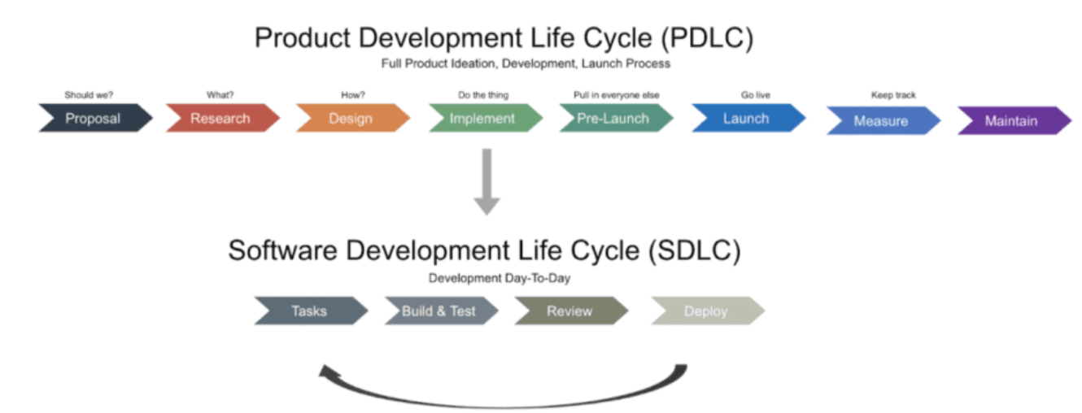

**Project planning -** tracks project evaluation, who involved in project, when project is complete

**Why planning**

1. Tracks project execution
2. Ensuring the budget and schedule of each and every step
3. Improves quality
4. Reduce project risk

**Tools for planning -**

1. Gantt charts - helps to visualize **task and projects** simultaneously
2. PERT chart - program evaluation and review technique **help in analyze the task, project and time required**
3. Work breakdown structure - organizing the team's work into sections
4. Project documentation - includes scope, schedules, risk analysis

**Steps in project planning -**

1. Define scope - list of goals, budget, deadline - helps in boundaries and responsibilities of team
2. Prioritize the task
3. Determine deliverables - in how many time what has to be deliver - deadline of task
4. Create project schedule - measuring project progress - outline of project

Why excel -

1. Simple to use and easy data manipulation
2. Many analytical tool like concat etc
3. Easy tracking and monitor
4. Many templates for project management

**Project time management -**

Manage the time to completion of the project

Scheduling the task and maintain the project timeline

Prioritize the tasks

**Plan schedule management** - process of establish procedures, documentation, developing, management and controlling project schedule

**Cost management -** managing cost of project - estimating budget and controlling cost so that project can be completed within approved budget

Plan cost management - managing and expanding - estimate cost - determine budget

Expert judgment - meeting - analytical techniques - group decision

Determine budget

Cost control - monitor and control process group

Earn value management - method to measure project performance with project baseline. Results in earned value analysis

**Quality Management -** includes creating and following policies and procedures that meet the project defined

**Quality -** degree in which characteristic fulfill requirement

**Customer satisfaction** - requirement and fitness of use

Precession - how fine the outcome is measured

Accuracy - correctness - close to desired value

Quality planning - activities project are planed

Quality assurance - ensure the product is carried out as per quality measure

Quality control - check are conducted to ensure quality improvements

**Characteristic of projects -**  Make the work easier for target audience - Produces unique outcome

Stakeholder - individual, group, or organization who may be affected by the decision, activity, outcome of project

Communication - 2 way process to transfer information

Communication channel - various media used from communication - mail, fax etc

Functional manager - handles business function - subject matter experts

Project manager - responsible for project and its quality - not technical expert

RACI Chart - responsible - accountable - consulted - informed

Develop project team - team building activities - training - recognition and reward - grounded rules

Risk - uncertain event or condition if occurs then has a positive and negative impact on project objective

Types of risk

External risk - like suppliers, subcontracts etc

Internal risk - arise within project - funding, resources and prioritization

Technical risk - technology used - requirements, technology and quality

Project management risk - like estimating, planning, communication

Classification of stakeholder - power, interest, influence

**Work breakdown structure (WBS)** - breaks the project into smaller and more manageable pieces called work packages - easy to manage

**Agile project management** - process by which project can be managed by breaking it into several stages

Why an agile project?

High product quality - building product as per stakeholders demand

High customer demand - deliver does not longer time, continuous and fast delivery

Reduce risk - project divided into

Agile - Ability to move quick

Interaction with team

Prioritize the work or task

Value - knowledge and customer value

feedback

Short term or long term

Drop some low priority task

Scrum Framework - help in dealing with complex problem and making it possible to deliver high quality products at the same time

Agile - ability to change and adapt changes based on requiements

why scope, outcome, priortization

cross functional team discussion

feedback survery when new feature deployed

Rose bud and thorn categories -> good, can be updated, negative

flexible to adpt change

just in time

Scrum -

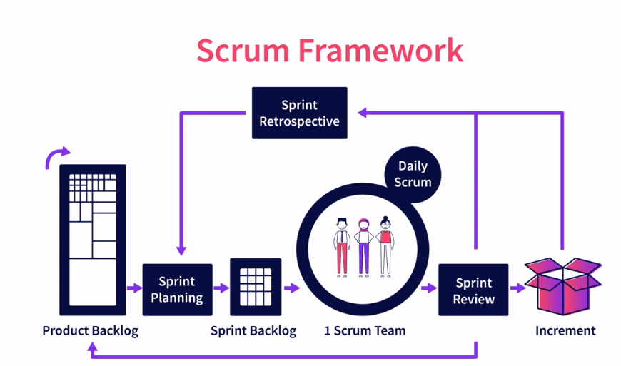

Scrum team -> Product owner - Scrum Master - Development team

Product owner - business representative on team

Define works

Priority of work

Communication between stakeholder, customer, team

Scrum master- responsible for effective work and team follow scrum

Ensure blockers, works to team

Development team - develop the feature and completed the task

Scrum Event -> Sprint, Sprint planning (plan the task based on priority), Daily scrum, Sprint review (team shows what they completed ), Sprint Retrospective is to plan ways to increase quality and effectiveness

Sprint Artifacts - Product backlog (order and priortised list of work), sprint backlog, increment(each sprint work + previous all work )

**Go to market Strategy**

1. Success metric -
   1. Define goals - traffic, total active users
   2. Time period
2. Who -
   1. target user
   2. Prioritize - frequency, spend
3. What do you as a product known for - adjective
   1. Eg easy to use, highly customisable
4. Where -
   1. From where users come from
   2. Innovation - silicon valley
5. When -
6. Understand competition
7. Value propagation
8. Inbound and outbound marketing -
   1. Inbound - target the specific audience and customer - social media post, blogs
   2. Outbound - designed to capture customer attention and sell the product - direct mail, ads, billboards etc
9. Content -
   1. Blogs

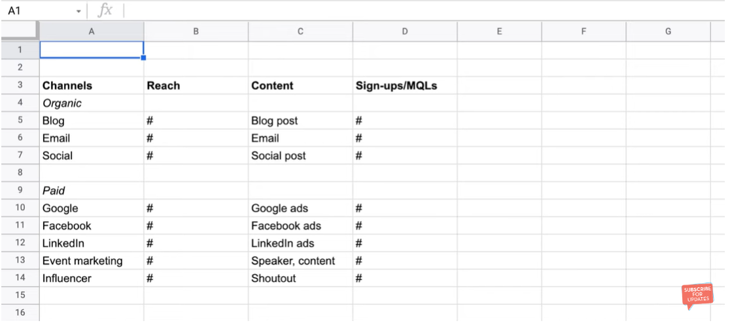

Pre launch giveaway - also from launch we are able to generate some user content

Blogs - create high quality content to attract more organic view

Recommendation system - like free trial

Social media influencers - marketing from social media

Prepare faqs before launch - because users has bunch of questions how it works

Email marketting

Mockup Images - images in home page